L1 Physical examination of the chest

A) Normal clinical pulmonary anatomy and physiology
- Angle of louis: 2nd intercostal space
- Horizontal fissure: 4th intercostal space(Separate the right middle lobe and right upper lobe of lung )
- Right Oblique/Greater fissure
- A curve, starts at spinous of T4,
- Cross 5th intercostal space laterally
- Follows the contour of 6th intercostal space
- Right superior part separate right upper lobe and lower lobe
- Right inferior part separate right middle lobe and lower lobe
- Left Oblique/Greater fissure
- A curve, starts at spinous of T3/T4,
- Cross 5th intercostal space laterally
- Follows the contour of 6th intercostal space
- Separate left upper and lower lobeV) Mediastinal outline structures
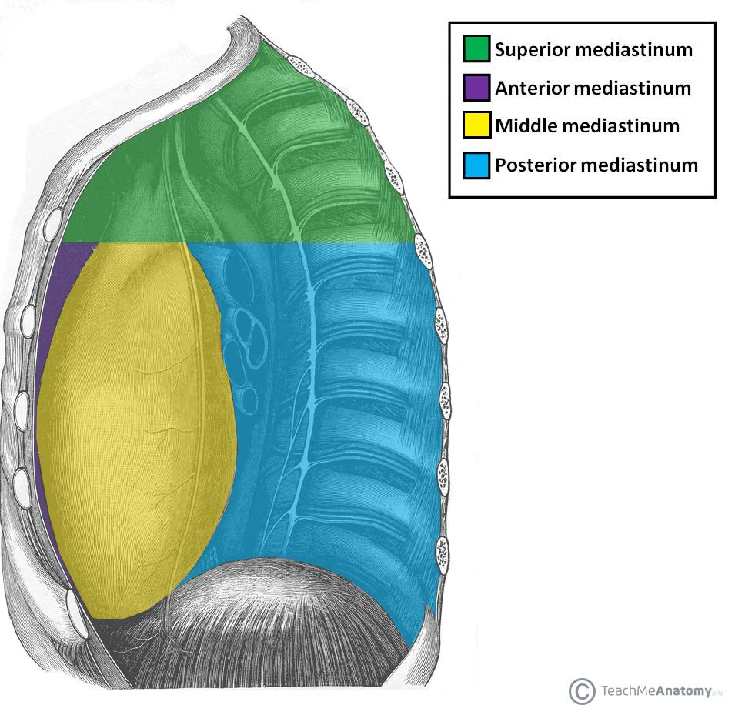
1) Superior vena cava: Right upper mediastinum
2) Right Atrium: Right middle mediastinum
3) Inferior vena cava: Right lower mediastinum
4) Aortic Arch: Left upper mediastinum
5) Pulmonary trunk: Left upper mediastinum
6) Left ventricle: Left lower mediastinum
7) Cardiac apex 5th intercostal space ------- left mid-clavicular line

VI) Others points
- Left lung is smaller under X-ray. Heart is there
- The medial parts of anterior rib is not seen under X-ray：Made of Cartilage
- PaO2 = partial pressure of oxygen in the arterial blood
- PaCO2 = partial pressure of CO2 in arterial blood
- Pneumonia = infection of lung parenchyma
- Bronchiectasis支氣管擴張 = dilatation of bronchi
- Lung abscess = pneumonia with form of cavities
- COPD = chronic obstructive airways disease
- Chronic bronchitis / emphysemaPart of COPD

B) Information at the bedside
I) Oxygen supplementation: Oxygen mask, Nasal cannula
II) Inhalers Deliver drugs
III) Oxygen concentrators: Long term low dose oxygen delivery
IV) Ventilators: For pulmonary failure patients
V) Peak expiratory flow meter (PEFR meter)
- Assessee air flow rate, but NOT volume
- Monitor disease severity in Asthma
- Asthma patients normally have a reduced PEFR at night
- Procedure
- Set zero of the meter
- Stand up straight
- Take a deep breathe
- Place the meter in mouth and blow out as hard, fast as possible
- Repeat 2 more times, write down the HIGHEST number
- If cough, then repeat again
- Same time doing it each day
- Limitations
- Effort dependent
- Not useful for patients with very poor lung function
- Pulse oximeter
- Check the ratio of Oxy- to deoxy- haemoglobin
- SaO2 %
- Affected by
- Skin colour
- Circulatory state
- Hb concentration
- Limitations
- <70%
- Presence of abnormal Hb
- Presence of dye
- Increased bilirubin
- Shock

C) Bedside skill

I) General examination

- Tachypnea (abnormal rapid breathing)
- Oxygen supplementation, sputum collection
- Breathing pattern: Breathlessness ?? (Normal 12-18 / min in adult)
- Cyanosis
- Clubbing :Loss of angle ,Floating sensation ,Drumstick appearance
- Swelling of head and neckSuperior vena cava obstruction

II) Inspection
- Asymmetry, scars, scoliosis & kyphosis(脊柱側彎/後突) ，prominent vein突起的
- neck and supraclavicular fossa鎖骨上窩
- Flattening / over-inflation（chest-deformity）
- Respiratory movements: diseased side moves less
- upper chest + lower zones 前後都要
- placing the hands exactly symmetrically on either side of the upper chest
- expansion of the lower zones assessed by stretching fingers and thumbs over the lower ribs.

III) Palpation
- Cervical lymph nodes
- Position of the media/stinum縱膈（trachea, apex beat)
- Chest expansion/Chest vibration on speech
- Chest wall：Mass /Pain/ Local Tenderness?

IV) Percussion
- symmetrical areas percussed on both side
- horizontally rest the left middle finger onto the chest wall between ribs
- wing the flexed middle finger of the right hand to percuss the left middle finger
- percussion of lung apex from posterior
- presence/absence of hepatic and cardiac dullness??

- Resonance
- All resonant EXCEPT liver and heart
- Percuss each intercostal space
- Lower border
- 6th intercostal space between sternum to the mammalian line
- 8th i.s. at midaxillary line
- 10th at scapular line
- 11th near the vertebrae
- Auscultation
- Breath sounds arise from turbulence in larynx and central airways
- Added sound: Wheeze, Crepitation爆裂聲

L2 History taking

1) Aetiology of disease
I) Congenital: ASD, patent Ductus
II) Hereitary:
III) Metabolic:
Gout (purine), Osteoporosis(calcium)
IV) Endocrine:
Cushing syndrome, Acromegaly
V) Immunological:
VI) Degerative:
Atheroscleosis
VII) Neoplastic
VIII) Infective
IX) Iatrogenic (人造)

2) Ways of effect on the host by disease
a) Derangement of functions
I) Disturbance of internal environment
homeostasis of the body fluid
e.g. hypercalcaemia
II) Disturbance of physiological function
Will gives rise to symptoms
b) Derangement of structures
Derangement of normal anatomical structure of the body
Will gives rise of signs

3) History taking
I) Name, Age, Sex
II) Chief Compliant (主訴)
III) History of present illness (現病史)
IV) Past History, Family history, obstetric history(既往史, 家族史, 婚產史)
V) Physical examination
1) Special signs
E.g. Finger Clubbing
2) Normal procedures
Cardiovascular, respiratory, CNS, Abdominal
Musculo-skeletal, Urinalysis
VI) Investigation
Function tests, imaging, blood and fluid tests4) 4 Principles in clinical bedside diagnosis
I) Commence with a process of exclusion and inclusion
II) Symptoms
Clinical manifestations of disturbance of internal environment of the
body and normal physiological functions
III) Signs
Derangement of normal anatomical structure of body
IV) Common diseases always come commonly

L3 Physical Examination of abdomen

A) Stigmata of liver disease
- Jaundice
- Not at medial and lateral corners of sclera
- Spider Angioma ***
- At superior vena cava drainage area
- Scattered telan/gi/ec/ta/sia *** 毛細血管擴張
- Dilated capillaries
- 5 signs of hand
- 1) Palmar erythema肝掌（手掌紅斑）
- 2) Clubbing of fingers and toes
- 3) Dupuytren’s contracture 掌腱膜攣縮症：Loss of tissue in the palm （First affects 4th & 5th tendons）
- 4) White nails
- 5) Flapping tremor：Cannot hold the hand steadily

- Fetor hepaticus 肝病性惡臭
- Special smell of breathe
- Severe hepatocellular decompensation
- Changes of body hair distribution
- Gynaecomastia 男性女乳症
- Ankle pigmentation + leg ulcers
- Associate with splenectomy 脾切除
- Signs of fluid retention
- Easy bruising, purpura (皮下出血)

B) Examination of the abdomen

a) Inspection
- Shape
- Scaphoid舟狀
- Distended：Fat, flatus(氣), faeces, fluid

- Umbilicus
- Depressed ：In fat abdomen
- Bulging / everted ：Increased intra-abdominal pressure (Ascites)
- Movement
- Pulsation：Thin patients
- Visible peristalsis：Intestinal obstruction
- Hernial orifices (疝氣)
- ASK PERMISSION

b) Palpation
- START FROM Lower Right Quarter

- Gross abnormalities

- Tenderness

- Liver
- Upper border: 5th intercostal space + mid clavicular line
- Lower border: 7cm under costal margin + mid clvicular line
- Palpable ?
- Characteristic of edge and surface
- Sharp ? Nodular ? Hard ?

- Spleen
- Along line joining UMBILICUS and Left anterior axillary fold
- Enlarged spleen have notches ***（Normally spleen is not palpable, but if it is enlarged two or three times of its normal size then it is palpable.）
- Method
1) Turn patients towards right
2) Hook spleen forward with hand at renal angle
3) Spleen may float to a more lateral position in presence of ascites

- Kidneys
- Right kidney lower than left

***Differentiation between spleen and left kidney
1) Spleen is anterior, kidney need bimanual palpation（雙手觸診）
2) Subcostal gap absent for spleen
3) Percussion dull for spleen
4) Notches for spleens > 10cm

c) Percussion
I)Ascites
a) Shifting dullness at flanks
b) Fluid thrill
d) Auscultation
I) Bowel sounds
II) Splashing
Pyloric stenosis

L4 Interpretation of blood gas

A) Way to measure arterial blood gas
- Use a fine needle and syringe to take blood from artery (radial artery橈骨動脈)
- Normal range:
- PO2: 80-100mmHg（10-13kPa）
- PCO2: 36-44mmHg （4.5-6.0kPa）
- pH: 7.36 – 7.44
- HCO3: 22-29mmol/L

B) Gas exchange and transport

Background
- Respiratory quotient = 0.8（RQ = CO2 produced / O2 consumed）
- Every 250 ml of O2 is used, 200 ml of CO2 is produced

Oxygen transport
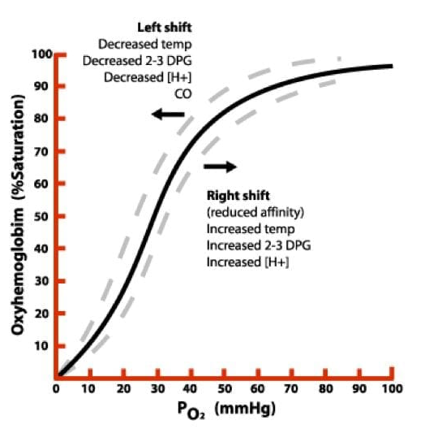
- Form ：
- Majorly bind to hemoglobin (1.39ml/g of Hb)
- 20mL O2 will be carried by 15 gram of Hb/100mL blood

- S shape Hb-O2 dissociation curve 氧離曲線 :
- Hb slight decrease in saturation at high PO2
- Hb great decrease in saturation at low PO2
- PO2 100mmHg (X axis) = 97% saturation (Y axis) = Artery
- PO2 60mmHg = 90% saturation
- PO2 40mmHg = 75% saturation = Venous)
- Factors affecting the affinity of hemoglobin for O2
- Shifting the curve to the right (Favors dissociate 有利於游離, carry得無咁好)
- Increase in PCO2, temp
- Increase in 2,3 Diphosphoglycerate （This chemical binds more readility to deoxy.RBC咁啲rbc就carry唔到O2）
- Decrease in pH
- Shifting the curve to the left (Favors carrying, tends not to dissociate )
- Decrease in 2,3 Diphosphoglycerate（This chemical binds more readility to deoxy.RBC）
- Increase in pH

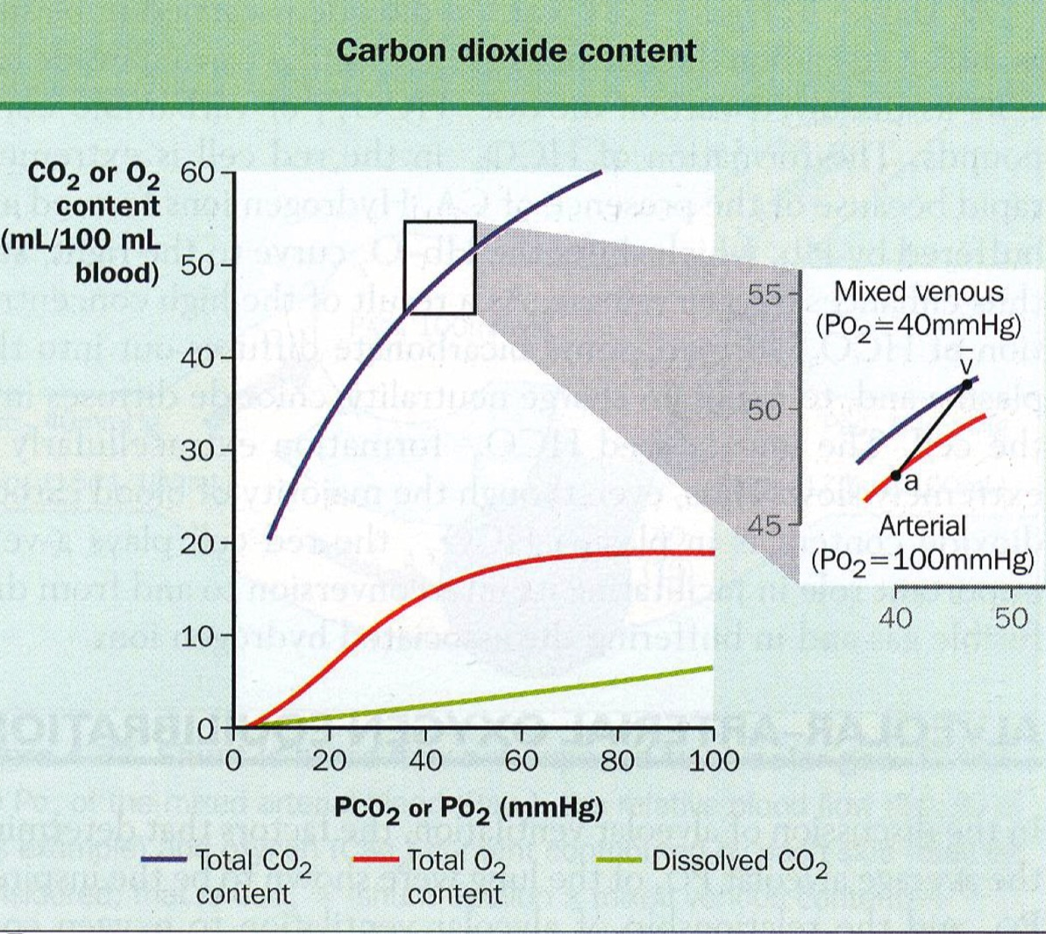
CO2 transport
- Form ：
- Majorly in form of HCO3- (85%)
- 5% in physical solution
- 10% binds to Hb / plasma proteins

- Factors affecting the affinity of hemoglobin for CO2
- Dissociation is usually linear over limited range between vein / artery
- Dissociation curve is steep（CO2 is removed rapidly from the blood in the alveoli）

Mechanisms of Hypoxemia 低血氧症
- Decreased of PO2
- Lower atmospheric pressure with normal fraction of inspired O2
- High altitude
- Alveolar hypoventilation 肺泡換氣不足綜合徵
- Reduced respiratory drive
- Diseases of respiratory muscles E.g. motor neuron disease, cervical spine injury
- Disease of chest wall or rib cage
- Disease of upper airways
- COPD
- Ventilation-perfusion mismatching
- Asthma, COPD, pulmonary embolism
- Acute respiratory distress syndrome
- Shunt
- Right-to-left shunt in congenital heart disease
- Diffusion defect

Respiratory failure
- Type 1 respiratory failure / oxygenation failure
- **Hypoxemia predominance, NO retention of CO2
- Defined by PO2 < 8kPa/60mmHg (Normally 10-13kPa)
- Due to
- Gas exchange units defect: Severe pneumonia
- Distal conducting airways defect: Asthma
- Pulmonary vasculature血管分佈 defect: Pulmonary Embolism

- Type 2 respiratory failure/ventilation failure/pump failure
- **Hypercarbia predominance + hypoxemia
- PCO2 > 6.5kPa, PO2< 8kPa (Normally PCO2 4.5-6.0kPa)
- Due to (5 reasons causing hypoventilation (9, II) ** )
- reduced breathing effort:
- decrease respiratory drive
- neuromuscular (myasthenia gravis重症肌無力,poliomyelitis小兒麻痹,motor neuron disease,cervical spine injury)
- chest wall (ankylosing spondylitis僵直性脊椎炎)
- increased resistance to breathing/increase in the area of the lung that is not available for gas exchange.
- upper airways: sleep apnea 睡眠呼吸中止
- asthma
- chronic obstructive lung disease.

Acid base balance
- Closely interrelated to respiratory status
- Equation: CO2 + H2O <——> H2CO3 <——>H+ + HCO3-

- 2 Types of acids in body
- Carbonic acid
- Can be effectively removed by the lung as CO2
- Measured by PaCO2
- Other Metabolic acids (lactic acid,pyruvic acid, keto-acids)
- Removed by kidney
- Measured by HCO3

- Type of diseases
- Respiratory acidosis
- Due to respiratory failure (COPD / SEVERE ASTHMA)
- Increase in PCO2, drives the equation to the right, increase H+
- Compensated by Kidney excrete H+ and increase HCO3 by renal retention
- Metabolic acidosis
- Due to renal failure, lactic acidosis, diabetic ketoacidosis
- Increased H+, drives equation to left, consuming more and thus
lowering HCO3
- Compensated by Increased ventilation to get rid of more CO2, restoring HCO3- / PCO2 ratio
- Respiratory alkalosis
- Due to hyperventilation in early asthma, pulmonary embolism
- Decrease in pCO2 drives the equation to the left, decrease H+
- Compensated by Decreased HCO3- by retention, restore HCO3- / PCO2 ratio
- Metabolic alkalosis
- Due to vomiting, retention of HCO3 associated with diuretic therapy
- Decrease in H+ drives the equation to right, increasing HCO3
- Compensated by Decrease in ventilation to increase pCO2, restoring HCO3- / PCO2 ratio

L5 Common Neurological diseases

A) Syncope 昏厥
- Transient 短暫的 Self-limiting (lost of conciousness)
- Due to inadequate cerebral blood flow
- Most often results from sudden blood pressure drop

- Reduced cardiac output
• Arrhythmia心律不整
• Outflow tract obstruction

- Hypotension
• Reduced intravascular volume
• Drugs
• dysautonomia

- Reflex syncope
• Neural reflexes modify heart rate and blood pressure inappropriately.

Vasovagal syncope
- The common faint
- Self-limiting systemic hypotension characterized by bradycardia and peripheral vasodilation
- Preceded by pre-syncopal symptoms of fatigue, nausea, weakness, sensation of impending faint
- Precipitated by prolonged standing, heat exposure, sudden painful or traumatic experience, in an upright or sitting position
- Signs of autonomic hyperactivity e.g. pallor, diaphoresis, nausea, sweating
- No post-event confusion but weakness frequently described
- Often recurrent and affects young people

B) Seizure
- Sudden change in behavior
- caused by electrical hyper/syn/chro/ni/zation of neural networks
- Acute symptomatic
- As a result of systemic（藥物、疾病或毒藥/影響全身系統的）or brain insult 腦損傷
- Insults include metabolic derangements, drug or alcohol withdrawal, encephalitis, head injury, stroke
- Unprovoked
- Unknown etiology
- Related to a preexisting brain lesion (remote symptomatic seizures)
- Epilepsy 癲癇
- At least 2 unprovoked seizures occurring more than 24 hours apart, or 1 unprovoked seizure with an expected increased risk for recurrence e.g. structural lesion such as stroke, history of traumatic brain injury
- Types of seizure：
- Focal seizures局部發作(aka partial seizures) with retained awareness
- Focal seizures局部發作with impaired awareness
- Generalized seizure
- EEG MRI for investigation

Syncope VS seizure
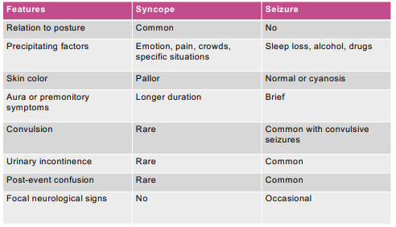

C) Vertigo 眩暈
- Sensation of spinning
- Due to a lesion within vestibular前庭pathways, either peripheral / central.

Cause (Peripheral)
I) Vestibular neuronitis 前庭神經炎***
- Severe of rapid onset, with nausea, vomiting, imbalance
- Likely viral cause

II) Benign paroxysmal positional vertigo (BPPV) 良性陣發性位置性眩晕
- Brief episodes片斷性 vertigo
- Caused by calcium carbonate debris碳酸鈣廢物 in semicircular canal
- Most common

III) Meniere’s disease 梅尼爾氏症
- Recurrent attacks經常性發作 of vertigo associated with auditory symptoms
- Abnormal fluid and ions in inner ear
- Two spontaneous episodes of rotational vertigo lasting at least 20 mins
- Audiometric confirmation of sensorineural hearing loss 感音神經聽損
- Tinnitus耳鳴 and/or a perception of aural fullness

Cause (Central)
- Stroke (Brainstem / cerebellar ischemic stroke)
- Multiple sclerosis多發性硬化（腦髓絕緣物質受到破壞）
- Vestibular migraine 前庭性偏頭痛

History
- Time course: single vs recurrent, brief vs sustained
- Associated symptoms:
- Central: other brainstem symptoms
- Peripheral: tinnitus, hearing impairment

Physical Examination
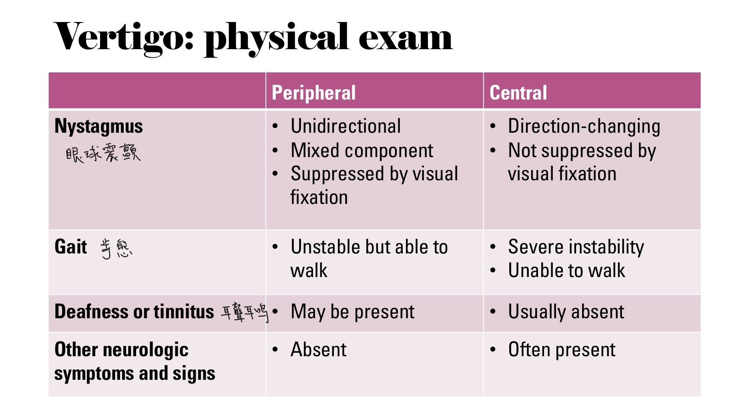
# GAIT(ref)
- Patients with acute peripheral vestibular lesion typically can stand but may veer（轉向） towards the side of lesion
- Patients with vertigo of central origin are often unable to stand without support; may have associated neurologic signs such as Dysarthria構音障礙, ataxia共濟失調，Hemiplegia半身痙攣型（偏癱）

D) Headache(Migraine偏頭痛)
- Recurrent attacks
- Aura預兆 : present in about 25% of patients
- Gradual development over 5 minutes to 1 hour
- Complete reversibility
- Most often visual

- Headache:
- Often but not always unilateral
- Throbbing搏動性
- Nausea, photophobia恐光症, phonophobia恐音症
- If untreated: lasts for hours to days

- Secondary headache
- Headache due to an underlying condition
- Brain hemorrhage
- Infections e.g. meningitis
- Space occupying lesion

- Headache: Red flags warranting neuroimaging
- “First or worst” headache
- Recent significant change in headache characteristics
- New onset headache after age 50
- Unexplained abnormal findings on physical exam

E) Neuropathy

#Polyneuropathy 多發性神經病變 :
- Causes
- Diabetes
- Systemic diseases: renal failure, crticial illness, hypothyroidism, vitamin deficiencies
- Autoimmune, paraneoplastic 腫瘤伴隨症候群
- Toxic: alcohol, chemotherapy, some drugs
- Hereditary 遺傳性
- Idiopathic 特發性
- Features warranting full evaluation
- Asymmetry
- Non-length dependence
- Motor predominance
- Acute onset
- Severe or rapidly progressive

#Upper extremity peripheral nerve syndromes
- C5-T1 nerve roots
- Deficit localization
- Causes:
•Compression: e.g. radiculopathy, carpel tunnel syndrome
• Inflammatory: herpes zoster, idiopathic (e.g. brachial neuritis)

- #Carpel tunnel syndrome
- Compression of median nerve in the carpal tunnel
- Risk factors:
- Obesity
- Pregnancy
- Diabetes
- Hypothyroidism

#Lower extremity peripheral nerve syndromes
- L2 to S4 nerve roots
- Causes:
- Compression by herniated disc椎間板突出, peroneal nerve compression at fibular neck, tarsal tunnel syndrome
- Inflammatory: herpes zoster, idiopathic, diabetic amyotrophy

#Facial weakness
- UMN lesion: Lower face weakness，Upper face spared，Example: stroke
- LMN lesion: Upper and lower face affected ,Example: Bell’s palsy

- Ramsay Hunt syndrome
- Facial weakness due to herpes zoster reactivation affecting the geniculate ganglion膝狀神經節 of the facial nerve

Diagnostic tools
- History and physical examination
- Blood tests
- Nerve conduction studies/electromyography
- Imaging: eg.MRI spine

F) Tremor
- Involuntary, rhythmic, oscillatory movement of a body part
- Rest tremor: occurs at rest
- Action: occurs with voluntary muscle contraction
- Kinetic
- Postural
- Isometric

A）Etiology 病因
- Rest tremor:
- Parkinson’s disease（Rest tremor，Bradykinesia，Rigidity，Postural Instability）
- Others: atypical parkinsonian syndromes, Wilson’s disease, thalamic/midbrain injury, demyelinating disease
- Action tremor:
- Enhanced physiologic tremor: drugs, caffeine, thyrotoxicosis, anxiety etc
- Essential tremor

B）Diagnosis
- History: other associated symptoms, aggregating factors
- Physical exam: rest vs kinetic tremor; other associated signs
- Blood tests when appropriate

L6 Live Function Test (Frank Lam)

Parameters in liver function test:
- Albumin
- Bilirubin
- Alanine aminotransferase (ALT), aspartate aminotransferase (AST)
- Alkaline phosphatase (ALP), gamma glutamyltransferase (GGT)

Other important investigations:
- Prothrombin time
- Arterial ammonia (NH3)
- Complete blood picture
- Autoimmune markers
- LDH
- AFP

Liver function tests:
- 3 aspects:
- A.Cellular integrity 完整性：ALT and AST（reflect on function）
- B.Protein synthesis：Albumin and PT凝血酵素原時間（reflect on function）
- C.Excretory markers：Bilirubin, ALP and GGT（reflect more on biliary system)

A) Cellular integrity: ALT and AST(Markers of hepatocellular injury)

Functions
- gluconeogenesis by catalyzing the transfer of amino groups from alanine acid or aspartic to ketoglutaric acid to produce oxaloacetic acid and pyruvic acid respectively

Origin
- ALT – cytosolic enzyme (100%) , more specific to the Liver
- AST – cytosolic (20%) and mitochondrial (80%) enzyme, found in liver, cardiac muscle, skeletal muscle, kidneys, pancreas, leukocytes and red cells
- ALT levels are more specific to hepatocyte injury

Common causes for elevated ALT and AST
- Viral hepatitis – chronic：HBV or HCV, exacerbation of chronic HBV；acute：A-E viral hepatitis
- Non-alcoholic steatohepatitis (NASH) 非酒精性脂肪肝
- Alcohol
- Drugs: Paracetamol, NSAID, antibiotics, statins, antiepileptics, anti-TB, herbal medications
- Autoimmune hepatitis
- Wilson’s disease威爾森氏症/ Haemochromatosis血鐵沉積症
- Congestive heart failure and ischaemic hepatitis

Elevated ALT and AST
3 aspects：
- Level of elevation (how high)
- Pattern of the elevation (what else)
- Subsequent profile (how long)
All these may provide clues for the cause of the abnormal LFT

Pattern of ALT & AST elevation
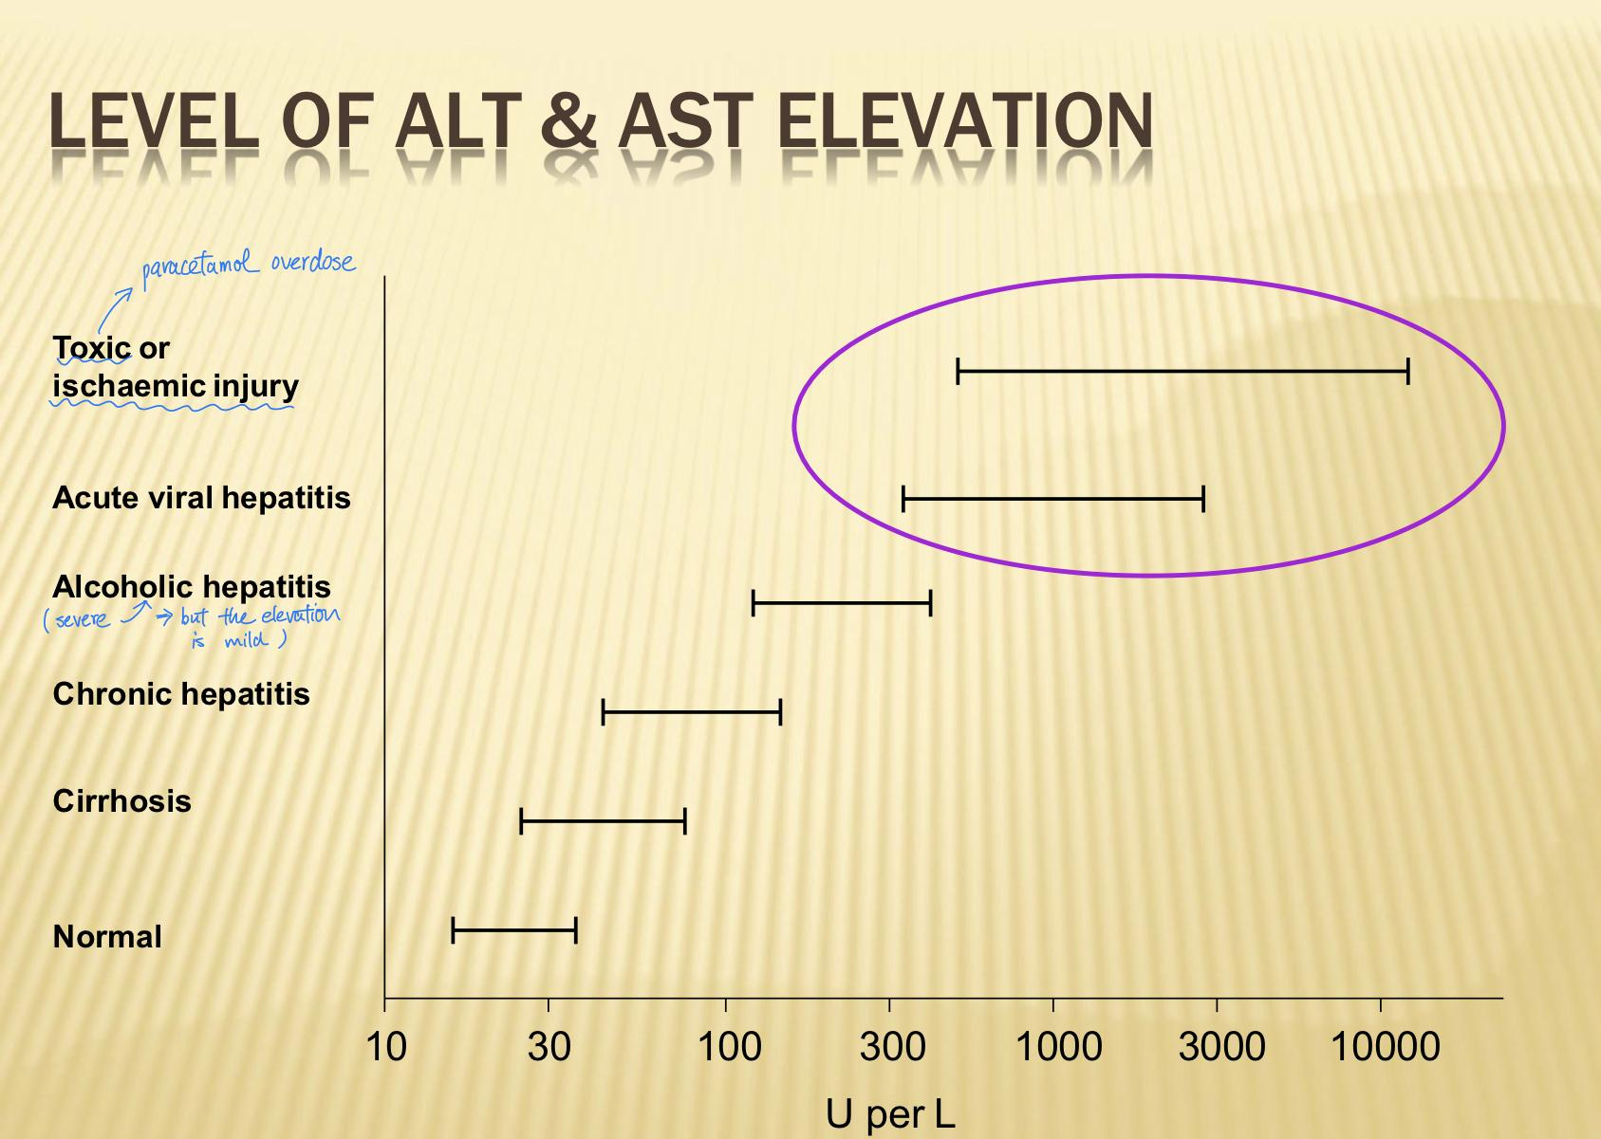
In usual circumstance, ALT level > AST level in diseases primarily affecting the liver except:
- Alcoholic hepatitis (AST > ALT, ratio >2:1)酒精肝
- Serum AST almost never greater than 500 U/L
- GGT, MCV
- Hepatocellular carcinoma 肝細胞癌（HCC）
- Viral markers, AFP, imaging
- Congestive heart failure
- Clinical information, US liver – enlarged liver, engorged hepatic vein
- Ischaemic hepatitis 缺血性肝炎
- Clinical information especially profound shock嚴重的休克
- LDH（Lactate dehydrogenase） – disproportional increase
- Subsequent profile of the ALT and AST level

Subsequent ALT and AST Profile
- Under normal circumstance, ALT and AST levels decrease gradually after treatment or removal of the causative agents
- Some conditions are associated with rapid decline of ALT and AST levels
- Acute ischaemic hepatitis
- Paracetamol overdose
- Cholangio/hepatitis 膽管肝炎（obstruction in biliary system）

B) Protein synthesis

1. Albumin
- Approximately 10g is synthesized and secreted daily
- Can serve as an index of liver synthetic capacity
- Several factors make albumin levels difficult to interpret
- Liver can synthesize albumin at twice the healthy basal rate
- Partially compensate for the decreased synthetic capacity
- Albumin has a plasma half-life of 20 days
- Level change slowly in response to alternations in synthesis
- Dependent on other factors
- Nutritional status
- GI loss, Urine loss

2. Prothrombin time (PT) 凝血酵素原時間
- Liver synthesized clotting factors II, V, VII, IX and X
- PT does not become abnormal until more than 80 percent of liver synthetic capacity is lost in chronic liver disease
- In addition, chronic cholestasis膽汁鬱積 with fat malabsorption脂肪吸收不良 may result in impaired vitamin K absorption leading to prolonged PT
- A trial of parenteral vitamin K is recommended
- PT should improve within a few days
- However, in patients with acute fulminant爆發性 liver failure
- Factor VII has a short half-life of only about 6 hours
- Sensitive to the rapid changes in liver function
- PT is very useful for monitoring in patients with acute liver failure
- Arterial NH3 should also be checked in patients with acute fulminant liver failure with or without sign of encephalopathy腦病變

C) Excretory Markers

Markers of cholestasis膽汁鬱積
- Bilirubin, ALP and GGT

1. Bilirubin膽紅素
- Formed from the lysis of red cells (the haem component) within the reticuloendothelial system - unconjugated bilirubin
- Unconjugated bilirubin – water insoluble
- Conjugated to bilirubin glucoronide – secreted in bile

2. ALP
- Origin: liver, bone (heat unstable),intestine,placenta (heat stable)
- Different isoforms can be differentiated by electrophoretic separation
- However, a good and simple way to confirm liver origin is to check GGT

3. GGT
A microsomal enzyme which transfers gamma-glutamyl groups from gamma-glutamyl peptides to amino acids and other peptides
- Isolated GGT elevation with normal ALP
- Drug: phenytoin, carbamazepine, barbiturates（鎮定劑）
- Alcohol
- Fatty liver

Elevated Bilirubin
- Elevated unconjugated bilirubin:
- Increased bilirubin production
- Haemolysis, ineffective erythropoiesis, resorption of haematoma
- Decreased hepatic uptake
- Drugs: e.g. rifampicin
- Decreased conjugation
- Gilbert’s syndrome
- Criggler-Najjar syndrome

Cholestasis膽汁鬱積
two conditions:
- blockage of bile ducts
- Disease that impairs bile formation in the liver itself (intrahepatic cholestasis肝內膽汁滯留症)

1. Blockage of bile ducts：
- Increase in bilirubin, ALP & GGT
- Acute bile duct obstruction from a gallstone
- AST & ALT may reach up to 500 U/L or more in first few hours and then decline (cholangiohepatitis膽管肝炎)
- ALP and GGT take several days to rise
- Both ALP and GGT levels are elevated in about 90% patients with cholestasis
- Further investigations：
- US or CT
- MRCP
- ERCP

Elevated ALP and GGT

Conditions other than biliary obstruction：
- Infiltrative disease: HCC, metastatic tumors, TB
- Liver abscess肝膿瘍
- Hyperthyroidism

Other diseases causing elevated ALP & GGT
- Primary biliary cirrhosis：Check antimitochondrial antibody and immunoglobulins
- Primary sclerosing cholangitis or Secondary SC：ERCP/MRCP

Cholangiohepatitis膽管肝炎
- History and clinical presentation
- Transient spikes in serum aminotransferase suggestive passage of CBD stone into duodenum
- AST shows more rapid changes due to shorter half life (17 hours. ALT: 30 hours)
- （第一日AST升幅高過ALT，跟住會跌，ALT會高返過AST）
- Medium AST elevation around 4.4 times upper limit of normal (highest >12 times upper limit of normal)

Identify Shock Liver 急性肝衰竭（aka acute Ischaemic hepatitis）
- Brisk rise and rapid resolution of LDH
- ALT / AST strikingly elevated, peak within 1-3 days, then fall rapidly
- ALT /LDH ratio <1.5 early in course of hepatitis
- Other evidence of end-organ damage eg. acute renal failure

UPDATE ON ：

Alcohol Hepatitis
- Maddrey Discriminant Function: 4.6 x (PT – control) + bilirubin (mg/dL)>32 = poor prognosis, 1-month mortality 35-45%
- Treatment options:
- Nutritional therapy (all forms)：Branch-chained amino acid formulas，Vitamin supplements
- Prednisolone 40mg daily for 1 month
- ALCOHOL ABSTINENCE! 酒精節制

Conclusion

#5 Cases of deranged LFT：
- Cholangiohepatitis (elevated ASP GGT;decline)
- first day AST>ALT (AST increases more rapidly, AST> 4.4times even 12 times)then ALT>AST
- ALP,GGT elevated(few days later)
- Drug-induced hepatitis
- ALT>AST
- drug history
- (overdose paracetamol未治療都會rapidly跌ALTAST的)
- Hepatitis E
- Viral: antigen test? History of viral infection？
- ALT>AST
- Anti-HAV IgM。HBsAg。Anti-HCV。Anti-HEV IgM
- Ischaemic hepatitis
- AST>ALT
- ALT，AST graduated elevated, peak within 1-3days ,then fall rapidly
- 慢升，3日peak，跌得頗rapidly
- shock（low BP）
- Alcoholic hepatitis
- AST>ALT,ratio>2:1
- GGT elevated（normal ALP）GGT好高！！！

#Determining the final diagnosis requires：
- History (drug history)
- Clinical presentation
- Other investigations
- Liver biopsy may be required

#HCC Marker：AFP
#Fibroscan：fibrosis/cirrhosis

Different liver diseases have different pattern of abnormalities of the liver function test
Urgent imaging may not be necessary（except Cholangiohepatitis）

L7 Physical examination of CVS

General examination Cyanosis

Cyanosis
Central: low oxygen saturation
Peripheral: comes with Central, or else inadequate peripheral circulation
Differential cyanosis: limited to lower extremities. PDA with pulmonary hypertension and
R-L shunt
Cachexia, Oxygen, Pallor

c) Inspection

- Face
1)Pull down Eyelid: Pallor?
2) Cheeks: Mitral facies (Rosy cheeks with bluish tinge) Severe mitral stenosis
3) Corneal arcus and xanthelasma Hypercholesterolemia
4) Conjunctival hemorrhageInfective endocarditis
5) Tongue: Central cyanosis
6) Turner Syndrome: Coarctation of aorta
7) Down Syndrome: Atrial septal defect / Ventricular septal defect
8) Williams Syndrome: Left and right heart obstruction

II) Hand

- Clubbing
- fluctuation of nail bed
- obliteration 閉塞 of lovibond angle
- Drumstick appearance
- hypertrophic osteoarthropathy
- Peripheral cyanosis
- Marfans syndrome 馬凡氏症
- Elongated finger and arm bones + Hyperflexibility
- Prolapse of mitral valve
- Aortic regurgitation
- Nicotine staining
- Radial pulse：Rate, rhythm, character, volume
- Collapsing pulse (洪脈): High volume pulse hits and falls suddenly quickly
- Aortic regurgitation ***

Bounding pulse Strong and powerful

Arterial Pulses
Rate: 60-100beats/minute
+ Rhythm:
Regularly irregular Second degree AVB, ectopics
Irregularly irregular —+ atrial fibrillation
+ Volume:
Diminished —Y Poor LV function, LV outflow obstruction, pericardial
effusion
Increased —Y "pounding" pulse
+ Characters:
Collapsing, delay, slow-rising, bisferian
Auscultation:
Bruit

CO2 retention / Liver failure / sepsis 膿毒症
III) Radio-femoral delayAortic coarctation
IV) Radio-radial delayaortic Coarctation 收窄/ dissection 撕裂
V) Regularly irregular2nd degree heart block
VI) Irregularly regularAtrial fibrillation

III) Neck
1) Right internal jugular vein pulsation
Check pressure 5CM up from sternal angle
If elevated ->4.5cm, then RVF, fluid overload and SVC obstruction
-> if decrease, Hypovolemia, dehydration

Jugular venous pressure
A wave:Reflect right atrial contraction and precedes carotid pulse
X descent :Reflect right atrial relaxation and passive pulling during right ventricular systole
C wave:Reflect closure of tricuspid valve and is separately visible
V wave: Reflect filling of right atrial during ventricular systole with tricuspid valve closed and
is roughly synchronous with carotid pulse
Y descent: Negative deflection of right atrial pressure during opening of tricuspid valve
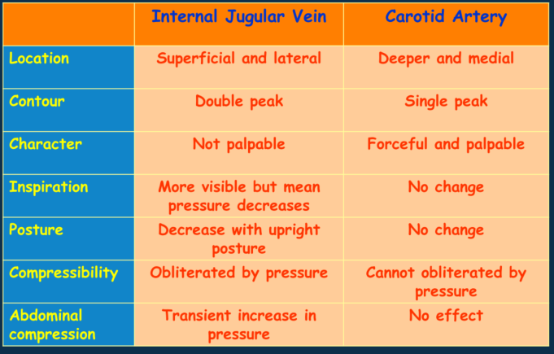

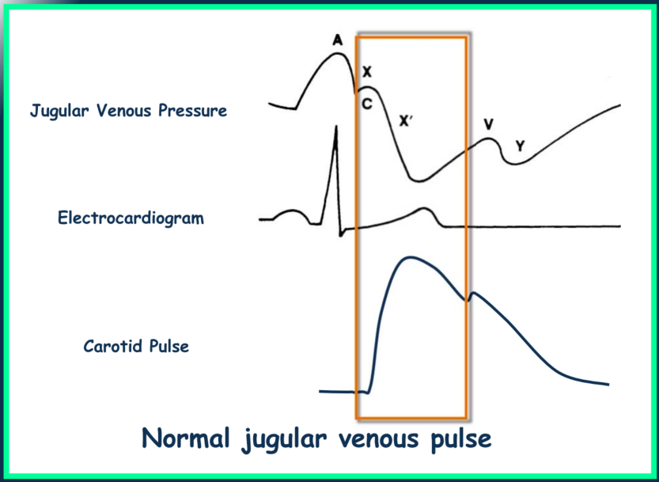
Cannon A wave: AV dissociation
Caused by Complete heart block, Atrial flutter, Asynchronous VP, VT(Ventricular tachycardia)
Giant V wave: TV(Tricuspid valve) regurgitation

2) Hepatojugular Reflex
I) Open mouth, lie, breathe normally
II) Right hand over RUQ and apply pressure 10s
III) Elevated JVP = sustained hepatojugular reflex
Right ventricular failure

3) Carotid pulses

Palpate and auscultate for carotid bruits 頸動脈有雜音
- If weak and small：Heart failure, aortic stenosis
- If large and bounding：Fever, hyperthyroidism, bradycardia
- Bisferiens雙峰脈 ref
- Increased arterial pulse with double systolic peak
- Aortic stenosis, regurgitation

IV) Pulsus alternans ref
Amplitude varies from peak to peak
rhythm regular
Left ventricular failure
V) Pulsus paradoxus ref
Pulse smaller on deep inspiration
Constrictive pericarditis
IV) Others ref
1) **Leg BP > armCoarctation of Aorta
2) **Asscess circulationTemperature,Colour
3) Scars / Pacemakers
4) Chest wall deformity
5) Non-pitting EdemaLymphedema
6) Ruptured baker’s cyst

d) Palpation
I) Apex beat
Displaced ?
Heaving? (Sharp and firm = Aortic stenosis)
Tapping? (Quick and light = mitral stenosis)
Thrusting (Diffuse and long = Mitral regurgitation)
II) Thrill
Palpable murmur over valvular regions
Mitral 5th lateral
Tricuspid 5th medial
Aotic 3th medial left and right

e) Auscultation
M — Mitral area (bell and
diaphragm). Left lateral
decubitus; axillary radiation
+ T —Tricuspid area (diaphragm)
P — Pulmonary area
(diaphragm)
+ A —Aortic area (diaphragm).
carotids
+ E— Erb's point (diaphragm):
lean forward in expiration
HS1
Increase Sl: tachycardia, mitral stenosis, high
cardiac output
Decrease Sl: first degree AV block, impaired LV
contraction
Increase splitting of Sl : TV closes significantly later
than MV e.g. RBBB; Absent splitting of Sl :
e.g. LBBB.
Varying Sl: complete heart block and atrial
fibrillation
HS2
increase P2: pulmonary hypertension,
ASD (atrial septal defect )
increase A2: systemic hypertension
Decrease S2: Aging, aortic /
pulmonary stenosis
Increase sp itting:
Delay closure of PV e.g. RBBB, RV
volume overload, pulmonary stenosis
Paradoxical splitting:
delay closure of AV e.g. LBBB, aortic
stenosis, HCMP
Fixed Splitting: ASD
HS3 abnormal
- S3: Oscillation of blood back and
forth between walls of ventricles; mid
1/3 of diastole — physiological in young
person, pathological in volume overload
- S4: atrial filling against an non-
compliant ventricle; immediately before
SI -> always pathological
- Gallop rhythm •heart failure

Murmur

Causes:
- High velocity flow
- Local obstruction
- Abrupt increase in caliber/ Drumstick deformation
- Mixed abrupt increase in caliber and obstruction

Characteristics
Characterization of a murmur
+ Grading: 1-6
1: Very faint, heard only after listener has "tuned in"; may not be heard in all positions
2: Quiet, but heard immediately after placing the stethoscope on the chest
3: Moderately loud
4: Loud, with palpable thrill
5: Very loud, with thrill. May be heard when the stethoscope is partly off the chest
6: Very loud, with thrill. May be heard with stethoscope entirely off the chest

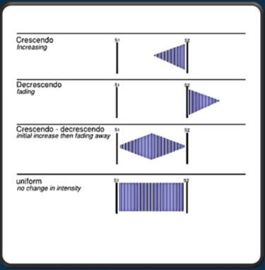
+ Timing: Systolic or diastolic (feel the carotid pulse or apex)
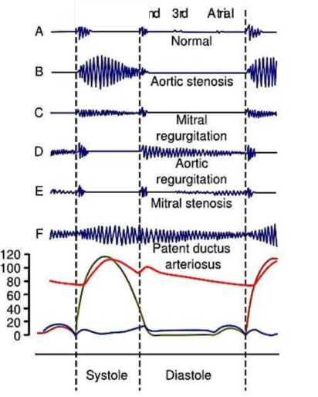
+ Character: pitch (low, medium and high) & quality (Blowing, harsh, musical, rumbling)
+ Site of maximum propagation and radiation: Axilla and neck
+ Effect of respiration: inspiration (Rt) and expiration (Lt)
+ Effect of maneuver (if needed)

Site and radiation

A)Pansystolic murmurs : (兩個鈣化)

1. Mitral regurgitation
- Loudest to apex，Radiate at axilla

2. Tricuspid regurgitation
- Tricuspid area

3. Ventricular septal defect
- loudest at left sternal area
- widely radiating

B）Ejection Systolic murmurs：

Aortic stenosis
- aortic area
- radiate to carotids

Pulmonary stenosis
pulmonary area
-May radiate to the back

Atrial septal defect
- pulmonary area
-May radiate to the back

C）Early diastolic murmurs

Aortic regurgitation
- loudest at left sternal border (Erb's point)
- best with patient exhale and lean forward

D）Mid diastolic murmurs

Mitral stenosis
- loudest at apex
- Left decubitus

E）Other diastolic murmur
- Graham steel: PR
-Austin flint: AR
Continuous murmur :
AS/AR
Patent ductus arteriosus
Left subclavicular area

L8 Common Resp diseases

Respiratory tract infections (RTI)

Upper RTI
- Common cold, flu-like illness, pharyngitis, laryngitis
- Mostly viral
- Symptoms: runny nose, sneezing, nasal blockage, sore throat, cough, sputum;
fever, chills, myalgia
- Usually acute onset and self-limiting

Lower RTI
- Bronchitis, pneumonia
- Mostly bacterial
- Symptoms: cough, sputum, haemoptysis,shortness of breath, pleuritic chest pain胸膜疼痛; fever, chills, poor appetite

Upper vs lower RTI
- Symptoms/signs
- Investigations
- Nasopharyngeal aspirate/swab for respiratory panel (RT-PCR or rapid antigen test for influenza)
- Chest X-ray
- Sputum culture (for bacteria)

Treatment
Supportive treatment
- IV fluids, oxygen supplement
- Chest physiotherapy
Specific treatment
- Antiviral for influenza
- Antibiotics (e.g. penicillin, macrolide, doxycycline) for pneumonia

Obstructive Airway diseases

1. Asthma
- A heterogeneous disease, usually characterized by chronic airway inflammation, leading to variable airflow limitation/bronchospasm
- Symptoms: cough, whitish/mucoid sputum, shortness of breath, wheeze; episodic
- Variable with common environmental triggers: e.g. weather change, cold air, URTI, air pollution, drugs，

2. Chronic obstructive pulmonary disease(COPD）
- Emphysema 肺氣腫, chronic bronchitis
- Cause: smoking, air pollution
- Symptoms: cough, sputum, shortness of breath, wheeze, exercise tolerance
- Usually middle age/elderly
- Progressive worsening; infective exacerbations惡化

Asthma vs COPD
- Background: atopy/allergy, smoking
- Age: early vs late onset
- Clinical course: episodic 偶發性 vs progressive
- Lung function test（expiratory volume decrease in COPD）

Treatment
- Mostly via inhalers
- Commonly used drugs：
- Inhaled corticosteroid
- Long-acting bronchodilators
- Short-acting bronchodilators

Lung cancer
- Most important cause: smoking
- Increasing trend of never smoking lung cancer
- Non-small cell (NSCLC) vs small cell lung cancer (SCLC)
- Staging: Tumour, Node, Metastasis
- Early-stage: resectable; Late-stage: metastatic or unresectable

Symptoms/signs
- Thoracic: cough, sputum, haemoptysis, shortness of breath, wheeze, chest pain
- Extrathoracic: related to metastatic sites e.g. neck lumps (lymph nodes), bone pain, limb weakness
- Paraneoplastic: endocrine, neurological
- Constitutional: weight loss

Pathological diagnosis
- Sputum cytology
- Biopsy of tumor sites
- Lung: bronchoscopy, CT-guided biopsy
- Neck lymph node: needle or excisional biopsy
- Bone, liver, subcutaneous lumps
- Molecular tests: e.g. EGFR mutation

Staging
- Computed tomography (CT) thorax/abdomen
- Positron emission tomography (PET)-CT

Treatment
- Small cell lung cancer
- Chemotherapy +/- radiotherapy (RT)
- Non-small cell lung cancer
- Early-stage: surgery +/- adjuvant chemotherapy
- Locally advanced: Chemo-radiotherapy
- Metastatic: Chemotherapy, targeted therapy, immunotherapy

Obstructive sleep apnoea (OSA)
- Sleep stages: Non-rapid eye movement (NREM)，Rapid eye movement (REM)
- During sleep (REM), loss of muscle tone → predisposed subjects with narrow upper airway may be obstructed

Risk factors:
- obesity
- maxillofacial 頜面部 anatomy

Symptoms:
- Snoring, sleep choking, nocturia夜尿, morning headache, daytime sleepiness
- Associations: metabolic syndrome,hypertension, coronary artery disease, cerebrovascular disease
- Using PSG as Dx

Management
- CPAP 持續陽壓呼吸器(continuous positive airway pressure ,簡稱CPAP）

L9 Basics about of ECG

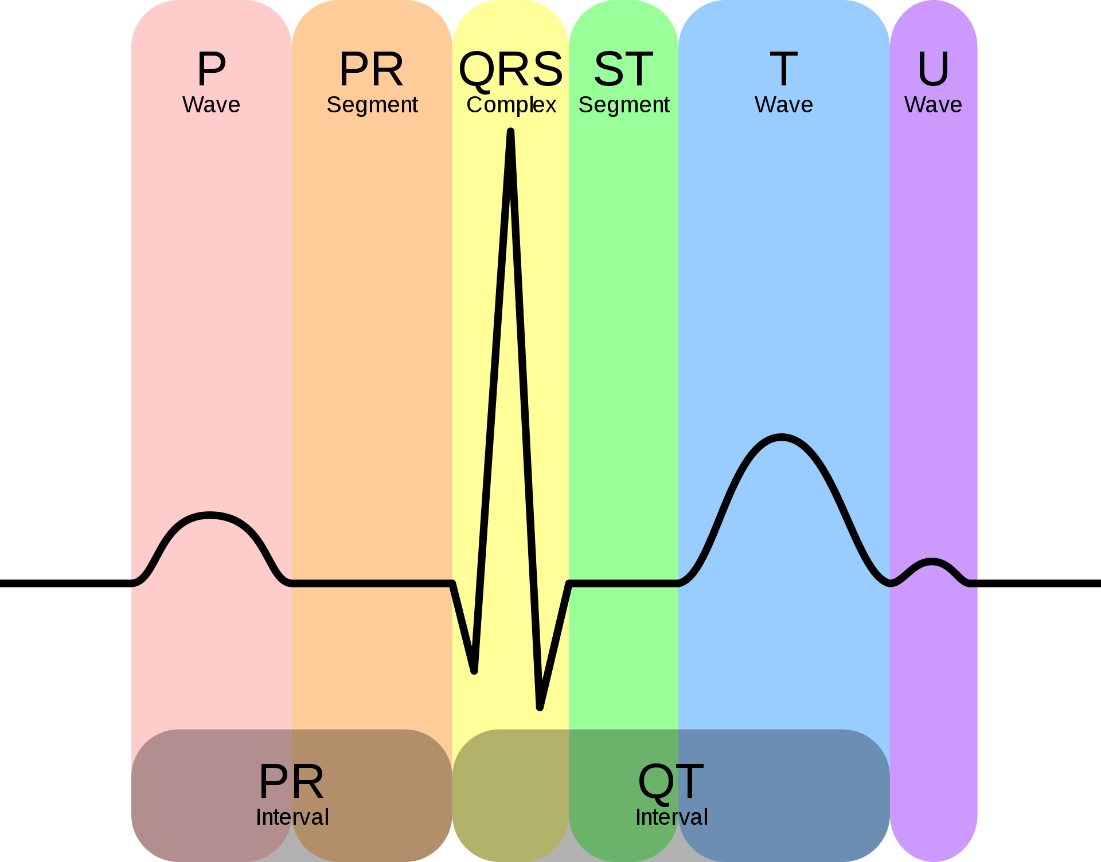

- The P wave represents atrial depolarization.
- The QRS complex represents ventricular depolarization.
Septal activation (Ventricular contraction)***Onset of QRS complex****
Free wall activation (Ventricular contraction)***Accomplishment of QRS
- The T wave represents ventricular repolarization.
- The U wave represents papillary muscle repolarization (pillar-like muscles seen within the cavity of the ventricles, attached to their walls).

a) Direction of electrical wavefront
Anything moving away from lead: -ve
Anything moving towards lead: +ve

b) Amplitude of electrogram
The larger the muscle, the larger the amplitude
The farther away the lead from the heart, the smaller the amplitude

c) Cardiac muscle contraction
Action potential maintained by Na+ / K+ gradient
Contraction is initiated by infiltration of Ca2+ into the muscle cells

d) Electrical conduction
I) Origin of electrical
Different types of cardiac cells spontaneously depolarize at differ.

Rate **The fastest pacemaker controls the heart rate
SA node 60-100 / min
Atrial cells 60-75/min
AV node 40-60/min
Ventricular cells 35-40/min

II) Normal conduction cardiac cycle ***
1) SA node dischargeNo deflection
2) Atrial muscle cells depolarization***P wave***
3) AV node activationNo deflection
4) Bundle of His activationNo deflection
5) Septal activation (Ventricular contraction)***Onset of QRS complex****
6) Free wall activation (Ventricular contraction)***Accomplishment of QRS complex***
7) Full ventricular activationNo deflection
8) Ventricular repolarization***T wave***
9) Late ventricular activation***U wave***Not seen in healthy person

e) Approach to ECG
I) Determine rate and rhythm
II) Look for any fast / slow arrhythmia (Normally 60-100)
III) Look for spot diagnosisAMI, LVH, BBB
IV) If not obvious, look forST-T ChangesPulmonary embolismElectrolyte and metabolic changes
V) Go through AxisP-Q-R-S-T
Systematic ECG Analysis
• Measurements (Timing)
– HR (regularity, rate)
– PR; QRS; QT; Axis
• Rhythm (Atrial / Ventricular)
– Atrial: sinus, atrial (passive / active)
– Ventricular: responding to the atrium, not responding to
the atrium (junction / ventricular)
• Conduction (AV node and HPS)
– 1st, 2nd, 3rd degree AV block, inter‐ / intra‐ventricular
conduction delay
• Waveform (QRS)
– Pathological Q wave, abnormal voltage, abnormal ST
segment, abnormal T wave, prominent or inverted U wave
• Interpretation

f) Causes of cardiac arrhythmia ref
I) Hypoxia
II) Ischaemia
III) Sympathetic Stimulation
IV) Drugs
V) Electrolyte disturbances
VI) Bradycardia
VII) Stretch

g) Symptoms of Arrhythmia ref
I) Asymptomatic
II) Palpitations
III) Dizziness, syncope
IV) Angina
V) Congestive heart failure
VI) Sudden death

h) The 12 ECG leads and axis
I) 6 Limb leads
1) I: 0 degree (left horizontal line)
2) II: 60 degree
3) III: 120 degree
4) aVR: -30 degree
5) aVL: -150 degree
6) aVF: 90 degree (Vertical)
II) 6 precordial (Chest)
1) V1: 4th intercostal space, Right side of sternum
2) V2: 4th intercostal space, Left side of sternum
3) V3: 5th intercostal space, between 2 and 4
4) V4: 5th Intercostal space, mid-clavicular line
5) V5: 5th intercostal space, between 4 and 6
6) V6: 5th Intercostal space mid-axillary line

50) A normal ECG
a) Normal conduction
I) Heart Rate: 60-90bpm
II) PR interval: 0.12 – 0.20 secAV conduction
III) QRS duration: 0.06 – 0.10 secIntraventricular conduction
IV) QT interval: < 0.40 secIntraventricular conduction
b) Normal Sinus RhythmP Waves in lead I and lead II must be positive
c) Waveform Descriptions
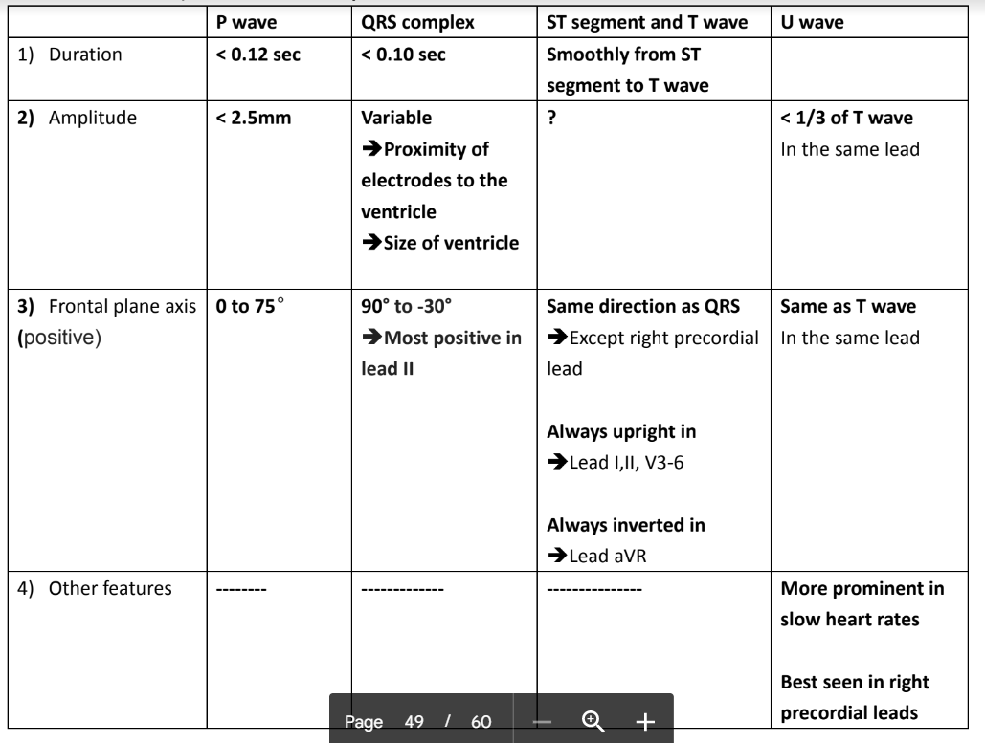

ECG on tachycardia
Supraventricular Tachycardia
• Atrial Tachycardia
• AV Nodal Reentrant Tachycardia
• AV Reentrant Tachycardia (Accessory
Pathway)
• Junctional Tachycardia
• (Sinus Nodal Reentrant Tachycardia)
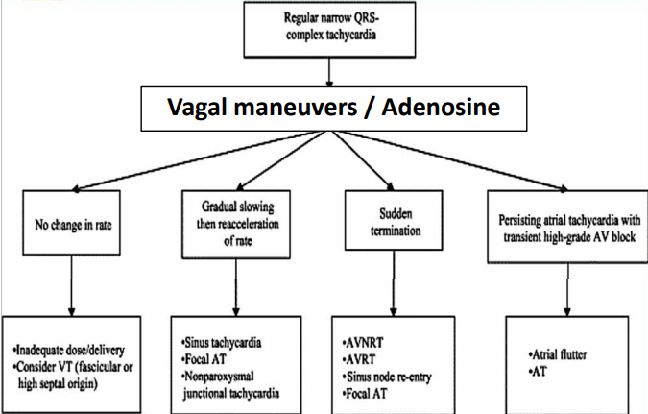
REF
a) Supraventricular tachyarrhythmia
I) Sinus tachycardia
II) Atrial flutter (Atrial rate = 300/min)
Regular Saw-toothed appearance ** (鋸齒型)
Symptoms
Fast palpitations, dizziness, heart failure
Underlying heart disease
Valves lesion
III) Atrial fibrillation (Atrial rate = 450 / min)
Irregular saw-toothed appearance
Heart rate dependent on
1) AV node conduction
2) ANS
IV) Paroxysmal Supraventricular Tachycardia PSVT (間歇性, 室上性)
***Inherited disease***
I) AV nodal reentrant tachycardia (AVNRT)
Amplitude reduce, P = QRS
Mechanism
Recirculation of the impulse within the AV node
II) AV reentrant tachycardia (AVRT)
Wolff-Parkinson-White syndrome (WPW-AVRT)
If orthodromic(Bypass and normal pathway same direction)
VERY short PR interval + Delta wave following P
If antidromic (Opposite direction)

Mechanism
Recirculation of impulse involving AV accessory pathway

b) Ventricular tachyarrhythmia
I) Ventricular tachycardia
If monomorphic (Come from 1 site)
140-200bpm
Regular rhythm, only widened QRS complex
If polymorphic (Come from more than 1 sites)
160-240bpm
Regular rhythm, only great increase in amplitude in QRS complex
II) Ventricular flutter
240-320bpm
Regular QRS complex only
III) Ventricular fibrillation
Irregular QRS complex only
IV) Torsades de pointes
Only QRS complex, spinning around the baseline
Keep changing their axis and amplitude

c) Ectopics (Premature contractions)
I) Atrial: P wave contour slightly different
II) Junctional: Nearly Without P waves, start at AV nodes
III) Ventricular (Premature ventricular complexes)
Inversion of T waves + Widened QRS complex
Monomorphic: unifocal
Polymorphic: multifocal
***R on T phenomenon
PVCs falling on the T wave of the previous beat

d) Summary of tachycardia
By comparing the rate of p and QRS
I) If p < QRS = junctional tachycardia
II) If P = QRS = PSVT
III) IF p > QRS = AF / Aflu, Irregular
Irregularly irregular tachycardia
AF, Aflu with variable block, Multifocal atrial tachycardia
Regularly irregular tachycardia
PSVT
e) General management of arrhythmia
I) Pacemaker implantWill give to spikes in ECG
II) Drug treatment
III) Radiofrequency ablation
IV) Cardioversion

ECG on other conditions
a) Acute myocardial infarction (AMI)
I) Q wave > 25% of R wave in amplitude
II) ST segment elevation (2 leads and > 1mm)
III) T wave inversion
IV) Site
Anterior AMI: V1 – V4
Posterior AMI: tall R wave in V1
Lateral AMI: V5, V6, I, avL
Inferior AMI: II, III, avF
b) Left Ventricular hypertrophy左心室肥厚
- QRS complex長
• S in V3 + R in aVL >28mm in M, >20mm in F
• R in aVL ≥11mm
• R in I + S in III >25mm
• R in aVF >20mm
• S in aVR >14mm
• S in V1 + R in V5/V6 ≥35mm
• R + S in any leads >45mm
• Associated with LAE, LAD, ST/T abnormalities
(Appropriate Discordance)
c) Right Ventricular hypertrophy
• Tall R waves in RV leads, deep S waves in LV
leads
– R in V1 + S in V5/V6 >10mm
– R/S ratio in V1 >1
– R >7mm, S<2mm or rSR’ with R’ >10mm
• RAD
• Incomplete RBBB pattern
• ST/T abnormalities (Appropriate Discordance)

AV block
• 1st Degree AV Block
– PR >0.20s
– Most common site of prolongation: AV node
• 2nd Degree AV Block 跳跳下無左QRS complex
– Mobitz type I (Wenckebach): Progressive prolongation
of PR intervals until a non‐conducted P wave occurs
– Mobitz type II: Fixed PR intervals followed by a non‐
conducted P wave
• 3rd Degree AV Block
– P and QRS are dissociated from each other
Inter‐ventricular Conduction Delay
• RBBB
– QRS ≥ 0.12s
– rsR’ or rSR’ in V1 with R’ wider than r wave
– Deep S wave in lead I and V6 with S wider than R or
≥0.04s
• LBBB
– QRS ≥0.12s
– QS pattern in V1 (small r wave can occasionally be seen)
– Broad notched slurred R wave in I, aVL, V5 and V6 with
onset to peak (R wave peak time) >0.06s
• Appropriate T wave discordance with BBB
– T wave should deflect opposite to the terminal portion
of the QRS
• Positive concordance can be normal
Fascicular Block
Left Axis Deviation
qR in I & aVL
R wave peak time in aVL
≥0.045s
Right Axis Deviation
rS in I & aVL
qR in III & aVF
RBBB + LAFB / LPFB = Bifascicular Block
Differential Diagnosis of
Wide Complex Tachycardia
• Ventricular tachycardia
• Supraventricular tachycardia with aberrant
conduction (RBBB, LBBB)
• Supraventricular tachycardia with
anterograde accessory pathway conduction
Features of VT
• AV dissociation
• Capture Beat
• Fusion Beat
• Negative concordance over precordial leads
• History of structural heart disease
• PVC of similar morphology

REF
d) Pulmonary EmbolismRight axis deviation + S1Q3 pattern
e) HypothermiaOsborne waves (J shape) **Prolonged intervals
f) Acute PericarditisGreat ST elevation
g) Hyperkalemia
I) Peaked T wave
II) Prolonged PR interval, flat P waves
III) QRS widening
h) Hypokalemia
I) ST segment depression
II) Flattening of T wave
III) Appearance of a U wave
i) Hypocalcemia
QT interval slightly prolonged
A PVC falls on the prolonged T wve
Set for a run of torsades de pointes
j) Digoxin OverdoseReversed tick (Inversion of T wave)

L10 Common infectious disease

Measle 痲疹
- Single-stranded enveloped RNA
- Morbillivirus genus
- Paramyxoviridae family
- Incubation period (7-14 days)

Symptoms
- High fever (40C)
- Koplik’s spots (in mouth)
- Malaise 萎靡，心神不寧
- Cough，Runny nose，Red eyes
- Then maculopapular 斑丘疹rash (3rd day) ：Trunk then whole body
- Three Cs: cough, coryza流鼻水, conjunctivitis
- Koplik’s spot in the mouth is pathognomonic（特有的）
- Maculopapular 斑性丘狀發疹,erythematous紅皮 rash ears, head, neck to whole body
- Change from red to dark brown then disappear

Complications
- Diarrhea
- Pneumonia (viral or secondary bacterial)
- Otitis media中耳炎
- Acute encephalitis
- Rare subacute sclerosing panencephalitis (SSPE)
- Corneal ulceration 角膜潰瘍
- High risks: HIV, chemotherapy, pregnancy, Malnutrition

Transmission
- Airborne disease
- Aerosol transmission via coughing/ sneezing
- Direct contact with fluid (nose/ mouth)
- Highly contagious接觸性傳染 – 90% without immunity
- sharing living space with patient
- Infectivity: 4 days prior rash and 5 days after onset of rash Measles

Treatment
- spportive
- NSAID or paracetamol

Prevention
- MMR vaccine at 12 months, booster at 4

Chickenpox 水痘 (ddx: shingles帶狀皰疹)
- Primary infection of VZV（Varicella-zoster virus）
- Incubation 7-21 days
- Symptoms:
- Prodromal前驅: nausea, loss of appetite, myalgia 肌痛, headache
- Low grade fever, oral sores and vesicular rash
- Vesicular rash: body and head; then arms and legs over 12 hrs
- Vesicles to blisters水泡 to pustules膿皰
- Contagious傳染性 until crust結痂
- Adults: more severe disease; pneumonia,hepatitis,encephalitis
- Diagnosis
- Swab of the vesicular fluid: DFA（direct fluorescent antibody）or PCR（polymerase chain reaction）
- Blood for IgM or IgG
- Treatment
- IV acyclovir or oral valacyclovir for 5 days （Best within 48hrs (rash)）
- Calamine lotion治療搔癢
- Antihistamines
- Prevention
- Varicella vaccine (Varivax) x 2
- Live attenuated vaccine
- VZIG（made from blood and contains antibodies to the varicella zoster virus） (pregnancy)
- Complications：
- High risk of congenital varicella syndrome先天性水痘症候群
- encephalitis, microcephaly, optic atrophy視神經萎縮 and damage to spinal cord

Zoster/Shingles帶狀疱疹

Clinical Features
- Reactivation of VZV infection
- Usually limited to 1 or 2 adjacent, unilateral dermatomes
- “Grape-like” lesions clustered on an erythematous base1,2
- Lesions usually heal within 4 weeks

Complications
- include neurologic, ophthalmic, cutaneous and disseminated

- Neurologic
- Postherpetic neuralgia 帶狀疱疹後神經痛 (PHN) most common
- Loss of sensation, allodynia 觸摸痛, cranial and motor neuron palsies, meningoencephalitis, hearing loss, vertigo

- Ophthalmic
- Visual impairment, ptosis眼瞼下垂, pain, facial scarring
- Keratitis （inflammation of the cornea）角膜炎：
- Occurs in about two-thirds of patients with herpes zoster ophthalmicus眼部帶狀疱疹。

- Cutaneous皮膚的
- Scarring
- bacterial superinfection

- Disseminated傳播
- More likely in immunocompromised patients

Diagnosis
- Swab of the vesicular fluid: DFA or PCR
- Blood for IgM or IgG

Treatment
- IV acyclovir or oral valacyclovir for 5-7 days
- IVIG for immunocompromised
- HIV, post transplant/chemotherapy
- gabapentin
- Calamine lotion
- Antihistamines

Prevention: Zostavax

Tuberculosis（TB肺結核）

DDx
- Pneumonia
- Carcinoma of the lung
- Aspergilloma 麴菌病
- Bronchiectasis 支氣管擴張

Symptoms:
- indolent fever（non-threatening）, chills, night sweats,loss of appetite, weight loss, fatigue
- Nail clubbing
- Pulmonary：
- Chest pain, prolonged coughing with sputum
- Hemoptysis 咯血
- Pneumothorax 氣胸
- Extrapulmonary：
- 15-20%；more common in HIV
- Meningitis腦膜炎, peritonitis腹膜炎, entericTB 腸內TB, pericarditis, lymphatics, genitourinary and bones/ joints
(Pott disease)
- 90% latent: asymptomatic

Diagnosis：
- AFB smear/ culture （Acid-Fast Bacilli (AFB) smear）(samples：sputum, peritoneal, pleural and pericardial fluid, EMU,tissue)
- TB-PCR
- Adenosine deaminase(pleural/ peritoneal)
- Mantoux test（aka Tuberculin Skin Test）: false +ve for BCG vaccine 接種過卡介苗 or past infection
- IGRA: QuantiFERON Gold (past infection)

Management & Prevention
- DOT： Directly Observed Therapy
- HRMZ for 6 months
- isonia/zid (INH), rifam/pin (RIF), etham/butol (EMB), and pyra/zina/mide (PZA)
- MDR-TB: resistant to HR (0.4% in HK)
- XDR-TB: 3/6 second line
- Second-line: quinolones, PAS, ethionamide, aminoglycosides, cycloserine, linezolid
• Prophylaxis (single agent)

HIV
- Viral Transmission
- sexual intercourse (hetero/ homosexual route)
- Blood-borne: IVDU/ exposure to contaminated blood (0.3%)
- perinatal transmission
- breast milk

Risk Factors
- High HIV viral load
- Lack of circumcision割包皮
- Presence of ulcerative STDs（sexual transmitted disease）

HIV antibodies testing

Management
- Fusion inhibitor: maraviroc (CCR5)，enfuvirtide (gp41)
- NRTI: zidovudine, lamivudine, tenofovir, stavudine
- NNRTI: efavirenz
- Integrase inhibitor: raltegrase, dolutegravir
- PI: ritonavir, lopinavir
- Early commencement increase survival
- CD4 around 500

Malaria瘧疾
瘧疾是一種可致命的嚴重疾病，由瘧原蟲屬的寄生蟲引致，包括惡性瘧原蟲、三日瘧原蟲、卵狀瘧原蟲、間日瘧原蟲及諾氏瘧原蟲。
- 5 species of Plamodia: P falciparum, P vivax, P ovale, P malariae, P knowlesi
- most：PF and PV
- mortality PF
Differentials:
- Dengue fever
- Tyhoid fever 傷寒及副傷寒分別由傷寒沙門氏菌及副傷寒沙門氏菌所引起
- Rickettsioses
- Leptospirosis 鉤端螺旋體症
- Melioidosis 類鼻疽(melioidosis) 是因為感染「類鼻疽桿菌」

Symptoms & Signs
- Asymptomatic for 1 week after bitten
- Incubation 2 weeks to 1 year
- Fever, chills, headache, abdominal pain, diarrhea and cough
- Febrile paroxysms病情突發 co-ordinated with rupture of red cells: 24 hours for PF, PV and PO, 3 days for PM
- Hepatosplenomegaly, thrombocytopenia血小板減少 and jaundice

Treatment:
1. P falciparum（PF）
- Artemisinin-based (Qinghaosu) discovered by Tu Youyou（intravenous）
- Arte/sunate青蒿素 2.4mg/kg iv twice daily on first day, then 2.4mg/kg iv daily till oral therapy (total 9.6mg/kg in 3 days) + Doxycycline 100mg bid for 1 week
- Quinine-based:
- Quinine gluconate 10mg/kg loading dose in NS, then 0.02mg/kg per min or Quinine dihydrochloride 20mg salt/kg loading dose in D5; followed by 10mg/kg every 8 hours
2. PV, PM & PO
- Chloroquine
- 600mg base PO stat and 300mg base 6 hrs later,
- 300mg daily for 2 days + Primaquine 15mg base po daily for 14 days in PV+PO to eradicate hypnozoites in the liver
- Mefloquine for chloroquine resist PV

L11 Common diseases of the CVS

Hypertension
Risk factors
- Family history
- Age
- Obesity
- Salt intake

Consequences
- Target organ damage
- Heart failure
- Stroke
- Myocardial infarction

BG: atherogenesis動脈粥樣硬化

Concepts：
- Factors: Hyperlipidaemia, Hypertension, Smoking, Homocysteine,Hemodynamic血流動力學 factors, etc
- Lead to endothelial injury/dysfunction
- Circulating platelets adhere to endothelial surface
- Leukocytes adhesion，Leukocyte migration
- Endothelial permeability increased
- LDL, VLDL and leukocyte accumulation；Smooth muscle migration
→ ingestion of oxidized LDL by leukocytes form foamy macrophage
- Macrophage and smooth muscles engulfing more LDL
- lymphocytes arrives
- Smooth muscle proliferation and accumulating extracellular collagen and fatty deposits

Coronary Heart Disease/Ischemic heart disease

A）Stable angina
- Angina pectoris心絞痛 is chest pain that results from cardiac ischaemia
- Usually caused by atherosclerosis reducing coronary blood flow
- Angina pain is usually felt in the centre of the chest, and also in the arm and/or the the neck
- The pain is dull and pressing
- Brought on by exertion or stress and relieved by rest after several minutes

B）Acute coronary syndrome /Unstable angina
- Unstable angina
- Non-Q-wave myocardial infarction
Acute myocardial infarction
Sudden cardiac death
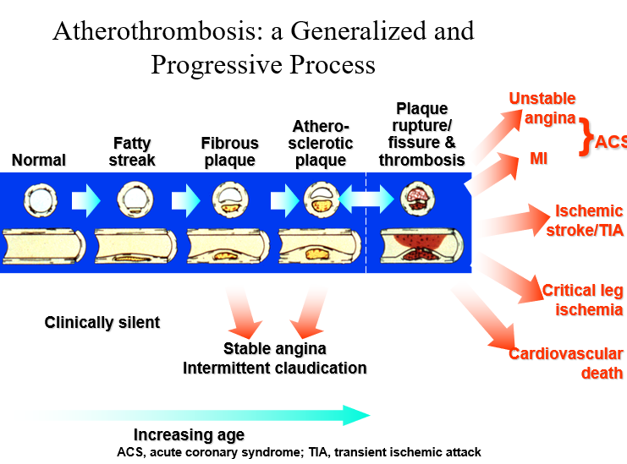

附加資料：一般將急性冠心症依其心電圖區分為ST波段 上升的心肌梗塞(ST elevation MI, STEMI)，非 ST波段上升的心肌梗塞(non-ST elevation MI, NSTEMI) ，以及非特異性心電圖變化的急性冠 心症 。多數心肌梗塞病人心電圖會出現 Q 波 ， 稱為有Q波的心肌梗塞(Q wave MI);但有些 則無Q波出現，稱為無Q波心肌梗塞(non-Q MI)。

C）Myocardial infarction
- The pain is similar to angina, but more intense and prolonged (>15 minutes)
- There may also be breathlessness due to pulmonary oedema

Diagnosis：
- Typical history
- Characteristic ECG changes (elevation of the ST segments)
- Rise in cardiac enzymes

Management
- Pain relief (morphine, nitrates)
- Heart failure (diuretics)
- Thrombolytics 血栓溶解機制
- Aspirin

Thrombolysis血栓溶解機制
- Thrombolytics血栓溶解劑 degrade the thrombus to reestablish coronary blood flow
- This reduces myocardial damage and saves lives
- Indicated in those with chest pain suggestive of myocardial infarction and ST segment elevation on ECG
- The earlier the treatment is started, the more benefit
- Contraindicated in patients who may be prone to bleeding
- Advanced age is not a contraindication
- Streptokinase鏈球菌激酶
- Recombinant tissue plasminogen activator（rt-PA）纖維蛋白溶酶原激活物（抗凝血藥）

Long term management after myocardial infarction
- Antiplatelet agent
- Angiotensin-converting enzyme inhibitor
- Beta-blocker
- Statin 降膽固醇處方藥

Stroke
- a syndrome of rapidly developing clinical signs of focal or global disturbance of cerebral function, with symptoms lasting 24 hrs or longer or leading to death, with no apparent cause other than that of non-traumatic vascular origin

- Types of stroke：
- Ischaemic：due to thrombosis or embolus, as well as hypotension, poor perfusion etc.
- Haemorrhagic：intracerebral and subarrachnoid haemorrhage
- Most strokes (70-80%) are ischaemic

A) Ischemic Stroke
- Atherosclerosis leading to thrombosis血栓
- Embolism栓塞（hv move to certain place and stuck the artery）
- Poor perfusion e.g. hypotension, arrhythmia 心律失常
- Prothrombotic states e.g. polycythaemia 多血症

B) Hemorrhagic Stroke
- 急性出血性中風可分為腦內出血(ICH)和蜘蛛膜下腔出血(SAH)兩大類,

1. Intracerebral Hemorrhage
- Risk factors:
- Hypertension
- Bleeding tendency – low platelets, leukaemia白血病, haemophilia血友病（缺乏凝血因子）
- Drugs – warfarin, heparin, thrombolysis
- Vascular abnormalities – aneurysm動脈瘤, arteriovenous malformation
- Tumours

Complications
- Intracerebral hemorrhage with rupture of the hemorrhage into the lateral ventricle of the brain. This lesion is likely to result in hemiplegia半身不遂 and could also be fatal if the brain hemorrhage and swelling cannot be controlled

The Clinical Presentations
- vary depending on the site and extent of the brain affected
- Common presentations include:
- Paralysis (hemiplegia)
- Numbness
- Facial palsy
- Visual field defect
- Loss of speech

2. Subarachnoid haemorrhage
- Sudden onset of severe headache
- Neck stiffness
- Photophobia
- Decrease in consciousness
- There is bleeding into the cerebrospinal fluid (CSF)

Management of Strok patient
- CT scan to detect area of damage and to look for haemorrhage
- Regular neuro-observation
- Monitor blood pressure
- Fluid management (often inc. intravenous fluids)
- Tube feeding in drowsy patients or in those who cannot swallow
- Prevent chest infection
- Care of the urinary tract
- Prevent pressure sores
- Physiotherapy，Speech therapy，Rehabilitation

L12 CNS examination – Cranial Nerve
（underline是ppt有講的nerve）
On old Olympus's Towering Top, A Finn and German viewed some hops.
- Olfactory nerve: Sense of smell.
- Optic nerve: Ability to see.
- Oculomotor nerve: Ability to move and blink your eyes.
- Trochlear nerve: Ability to move your eyes up and down or back and forth.
- Trigeminal nerve: Sensations in your face and cheeks, taste and jaw movements.
- Abducens nerve: Ability to move your eyes.
- Facial nerve: Facial expressions and sense of taste.
- Auditory/vestibular nerve: Sense of hearing and balance.
- Glossopharyngeal nerve: Ability to taste and swallow.
- Vagus nerve: Digestion and heart rate.
- Accessory nerve (or spinal accessory nerve): Shoulder and neck muscle movement.
- Hypoglossal nerve: Ability to move your tongue.

I) Olfactory Nerve (1st nerve)
- Lay below the frontal lobe
- If dysfunction, can lead to frontal lobe depression ，Causing low limb dysfunction
- Examination：Each nostril individually，Use aromatic but no irritant agents

II) Optic nerve (2nd nerve)
- Quantitative testing
- 20 / 60 = normally can see 60 feets away, but now only 20
- pupils：size(1-6mm),shape(regular/irregular), symmetry
Test for
1) Visual acuity：eye by eye；counting fingers
2) Visual field：eye by eye；Confrontation test (by comparing the field between patient and examiner
a) Total dysfunction：Defect in optic nerve
b) Lateral half in both eyes：Defect in the junction of 2 optic nerves (Optic chiasm)
c) Lateral half of one and medial half of another：Defect in optic tract（Homonymous hemianopsia）
d) Quarter of both eyes：Defect in near optic radiation
e) Lateral half of one and medial half of another + central dot
3) Direct light reflex：Shine to left eye, left constrict
4) Consensual 交感性 light reflex：When shine to left eye, both pupils should constrict
5) Accommodation reflex：Accommodate looking at distant and near object
6) Fundus 底

III) Ocular movements (Oculomotor, Trochlear, Abducent 3,4,6)
H test ** Examine 6 muscles，1 hand length，Ask the patient to follow your finger

IV) Trigeminal Nerve (5th nerve)
- Motor function：Muscle of mastication
- Sensory（3 Division）：
- Ophthalmic division：Forehead, nose, upper eyelid
- Maxillary division：Cheek, lower eyelid, upper lip (Cheek)
- Mandibular division：Lower lip, lower face and jaw (Chin)
- Corresponding Reflex ：
- Jaw jerk頜反射
- Corneal reflex角膜反射：
- Afferent – Ophthalmic division of V
- Efferent – Facial Nerve (VII)

V) Facial (VII)
- Muscles of facial expression
- Frowning 皺眉頭 (Upper face)
- Bilateral innervation雙側 ***
- Blowing cheek (Lower face)
- Only unilateral innervation ***
- Upper motor neuron lesion：Weakness of the contralateral lower face，bilateral forehead.
- Lower motor neuron lesion: Whole of ipsilateral face weak.

- Taste of anterior 2/3 of tongue
- Salivary secretion
**Commonly, block by** Parotid gland tumour ，Trauma in the face under ear lobe

VI) Vestibulocochlear Nerve (Deafness) (VIII)
1. Rinne’s Test ** (Normal Air conduction >> Bone conduction)
- Put the tuning folk onto mastoid until no sound is heard
- If you hear by normal hearing afterwards, then it is proved that air >>bone
2. Weber’s test **
- Put tuning folk onto the top of cranial
- The defected side will hear soft sounds
EXCEPTION **
Conductive Deafness will hear louder sound in the defected side
Absence of noises

A) Conductive Deafness
- Sound not transmitted to cochlear
- ear wax，middle ear damage
- Bone conduction >> Air conduction
B) Sensorineural Deafness
- Sound Transmitted to cochlear but sensation affected
- VIII nerve injury，tumor

VII) Glossopharyngeal nerve (IX) 舌咽神經
- Test：Position and movement of soft palate and uvula
- Gag reflex (Afferent part) ：By touching the back of tongue, initiating the swallowing reflex
- soft palate,pharynx,ear canal,mainly sensory
- Taste and sensation of posterior 3rd of tongue

VIII) Vagus nerve (X)
- Pharynx, larynx,viscera,somatic,
- Autonomic E.g. Heart beat Eg. GI motility
- Motor and sensory
- Test: Gag reflex (Efferent part)

IX) Accessory nerve (XI)
- Sterno/cleido/mastoid muscle 胸鎖乳突肌：Rotate head to the opposite side
- Trapezius muscle ：Shrug shoulders against resistance

X) Hypoglossal Nerve (XII)
Motor to intrinsic and extrinsic tongue muscle
Test for
I) Atrophy
II) Fibrillation
III) Deviate on protrusion
IV) Tongue movement
V) Power
****E.g. Right XII pulsy****

CNS examination – Upper limb(Ref?)

a) Motor System

- Appearance
- Symmetry, Deformity
- Muscle wasting / Hypertrophy
- Muscle fasciculation肌肉顫動
- Muscle Tone
- Increased tone（Cog-wheel type，Lead-pipe type，Clasp-knife type）
- Decreased tone

- Muscle Power
1) Serratus anterior (Looking for winging of scapula)C5,C6,C7 root, long thoracic nerve
2) Shoulder abductionDeltoid, C5-C6 root, Axillary nerve
3) Elbow
Extension: Triceps, C6,C7,C8, Radial nerve
Flexion: Biceps, C5, C6, Radial + Musculocutaneous nerve
4) Finger
Extension: Extensor digitorum, C7,C8, Posterior interosseous ner.
Flexion:: Flexor digitorium profundus, C7, C8
2-3 finger: Median nerve
4-5 finger: Ulnar nerve
Abduction: C8 T1, Ulnar nerve
5) Thumb
Extension: C7, C8, posterior interosseous nerve
Opposition: C8 T1, Median nerve

b) Reflex System
I) Bicep Jerk:
C5, C6, Musculocutaneous nerve
Palpate and strike the bicep tendon with tendon hammer
Bicep contraction and elbow flexion
II) Tricep jerk
C6,C7,C8 Radial nerve
Strike a few inches above the olecranon process
Tricep contraction and elbow extension
III) Supinator Jerk
C6, C7, Radial nerve
Strike lower end of radius
Elbow and finger flexion
IV) Hoffman reflex
C7,C8, Flick the terminal phalanx
Thumb flexion indicates hyperreflexia
c) Sensory System
Consider root or peripheral nerve
I) Sharp pain (Pin prick)
II) Dull pain (Pin prick)
III) Temperature

CNS examination – Lower limb(Ref?)

a) Motor System
I) Appearance (same)
II) Muscle Tone (same)
Alternatively flexing and extending the knee and hip
Rolling from side to side
III) Muscle Power
1) Hip
Flexion: L1, L2, L3, Femoral nerve, ilio-psoas
Extension: L5, S1, S2, Inferior gluteal nerve, Gluteus maximus
Abduction: L4, L5, S1, Superior, gluteal nerve
Gluteus minimus, medius and tensor fasciae latae
Adduction: L2, L3, L4, Obturator nerve, Adductors
2) Knee
Flexion: L5, S1, S2, Sciatic Nerve, Hamstring
Extension: L2,L3,L4, Femoral Nerve, Quadriceps
3) Ankle
Dorsiflexion: L4,L5, Deep peroneal nerve, Tibialis anterior
Plantarflexion: S1, S2, Tibial nerve, Gastrocnemius, soleus
4) Toe
Extension: L4, L5, Tibial nerve, Tibialis posterior
Inversion: L4, L5, Tibial nerve, Tibialis posterior
Eversion: L5, S1, Superficial peroneal nerve
Peroneus longus and brevisb) Reflex System
I) Knee jerk:
II) Ankle jerk
III) Plantar responseBabinski sign
c) Sensory System
Consider root or peripheral nerve
IV) Sharp pain (Pin prick)
V) Dull pain (Pin prick)
VI) Temperature

